Workforce Housing in the Upper San Miguel Region
Building for Actual Demand
An Independent Assessment of Affordability, Demand, Delivery Costs, and Regional Carrying Capacity — and a Decision Framework for Publicly Subsidized Housing
Prepared for the residents and public entities of the Town of Telluride, the Town of Mountain Village, and San Miguel County, Colorado
Prepared by Livable Telluride · August 2026
DRAFT FOR DISCUSSION — consolidates and supersedes the July 31, 2026 assessment and the August 2026 road map
Important notice
Purpose. This report assembles, in one place and in plain language, the publicly available evidence on workforce housing in the upper San Miguel River valley (the “Region”): what housing costs to deliver, what residents earn and can afford, what demand the public programs have actually experienced, and the condition of the shared infrastructure that any additional housing must rely upon. It then converts that evidence into a decision framework — an objective, rule-based method for evaluating any proposal that requests public money, public land, density, or fee waivers for housing.
Basis of preparation. The analysis draws exclusively on public sources: adopted policies and ordinances, engineering master plans, audited financial statements and adopted budgets, state and federal datasets, certified lottery records, and — where no official record exists — published news reporting, identified as such. Each material figure carries an endnote identifying its source; notes marked [E] are Livable Telluride calculations and state their methods and assumptions.
Reliability grading. Grade A: official, adopted, or audited sources. Grade B: professional studies with stated sample sizes. Grade C: news reporting or single observations. Grades are noted in Appendix A and in the endnotes.
Limitations. Livable Telluride is an independent community organization, not a licensed engineering, accounting, or municipal advisory firm. Dollar figures are as reported in 2024–2026 sources and are not adjusted for inflation. Where public records conflict, the report says so. Corrections are welcomed and will be published.
A note on tone. The findings in this report are direct. None of them argue against workforce housing. They argue for complete arithmetic: building what residents demonstrably need, pricing it where they can pay, counting the full public cost, and deciding deliberately how much growth the Region intends to carry.
Definitions

Term | Definition
AMI (Area Median Income) | The Region's benchmark middle income, published annually by the State. Under the 2025 table used by the Town of Telluride, 100% of AMI is $83,700 for a one-person household and $95,600 for a two-person household. Program limits and rents are expressed as percentages of AMI.
Income-restricted housing | Housing subject to recorded restrictions on who may occupy it (generally local employees within income limits) and on rent or resale price. Includes deed-restricted units, where the restriction runs with the property's deed.
Tier | The income step used to set rent in the Town of Telluride's rental portfolio, lettered A (lowest) through J (highest).
Market-rate housing | Housing not subject to occupancy or price restrictions.
Public subsidy | The public funds required to bridge the difference between what a unit costs to deliver and operate and what its occupants pay.
Need-catching housing | Housing sized and priced for households already living or working in the Region: the current workforce, the overcrowded, the displaced, and in-commuters the Region chooses to repatriate.
Growth-accommodating housing | Housing intended to enable economic expansion by attracting workers for new or unfilled positions. A legitimate policy objective with materially different economics, evaluated separately in this framework.
Restriction purchase | Acquiring a permanent occupancy or price restriction on an existing home in exchange for payment, as in Vail's InDEED program — creating a workforce unit without construction.
Efficiency frontier | The ranking of housing instruments by net public cost per worker housed per year; the frontier consists of the instruments no alternative can beat on both cost and benefit.
MGD | Million gallons per day; the standard measure of water and wastewater plant capacity.
BOD | Biochemical oxygen demand; the standard measure of wastewater strength. The regional treatment plant is constrained by waste strength before water volume.
LOS (Level of Service) | The A-through-F grading scale used by traffic engineers for intersection performance. LOS F denotes failure: long, unstable delays.
The gondola | The free aerial transit link between Telluride and Mountain Village, in service since 1996 and approaching the end of its design life.

Executive summary
Public discussion of housing in the Region generally begins with a single question: how can more units be built? The evidence assembled here indicates that this is the wrong starting point. The record supports a more precise set of questions: what should be built, for which households, at what public cost per unit, with what return per public dollar, and within what limits of regional infrastructure and public safety.
The assessment reaches ten principal findings:

Ref | Finding
F1 | Local wages do not support local rents. Workers in the Region's two largest employment sectors can afford $960–$1,230 per month under the standard 30%-of-income measure; the median market rental is $1,848 and the Telluride median is approximately $3,056. (Section 4)
F2 | Demand for below-market housing is deep at low price points. A 2023 waitlist reopening in Mountain Village received 50 applications within two hours; a 2026 affordable-ownership lottery drew six qualified households per available unit. (Section 5)
F3 | Demand is nearly exhausted at the price points where new supply was set. The 2024 lottery for the Voodoo project, with rents targeting households at 110–170% of AMI, drew 33 applicants for 27 units; five units remained unleased that December. (Section 5)
F4 | The January 2025 conversion to income-based rents functioned as an unintended pricing experiment: 82 renewals increased (35 by more than 49%), and by April 2026 approximately 24% of the Town's rental portfolio stood vacant. The Town's housing director attributed the vacancies to pricing, not demand. The rent formula has since been reduced. (Section 5)
F5 | Delivery costs make every new below-market unit a substantial public investment. At the Voodoo project's actual cost and financing, the public share ranges from approximately $644,000 per unit at the highest rents to approximately $1.03 million at the rents for which demand actually exists. Purchasing occupancy restrictions on existing homes, by comparison, has cost Vail approximately $62,000–$68,000 per unit. (Section 6)
F6 | Shared infrastructure is at or beyond rated capacity. The regional wastewater plant has exceeded its waste-strength rating, holds an expired permit under administrative continuation, and faces a replacement estimated well above $133 million. Two gateway intersections are projected to fail under background traffic growth alone. Gondola replacement, estimated at $120–150 million, is unfunded and its dedicated revenue is under appellate challenge. (Section 9)
F7 | Approximately 84% of the County's officially identified 1,114-unit housing need serves growth (commuter relocation, unfilled jobs, and projected job creation) rather than existing residents. The choice between housing the current workforce and subsidizing growth is therefore the threshold policy decision, and it has not been made explicitly. (Sections 2 and 10)
F8 | No evacuation clearance-time analysis exists for the Telluride box canyon, despite the County's own hazard plan describing wildfire evacuation as a principal concern. This is the single most consequential absent number in regional planning. (Sections 9 and 11)
F9 | Ranked by net public cost per worker housed, the Region's housing instruments differ by more than an order of magnitude — and its most-used instrument fails a break-even test. Repricing vacant public units, purchasing restrictions, and master-leasing house a worker for roughly $2,000–$15,000 per year; bespoke construction at Voodoo-class costs exceeds the entire measurable annual benefit of housing the worker. (Sections 7 and 8)
F10 | Under the need-catching objective, the honest program is finite and affordable: on the order of 250–400 beds, deliverable for approximately $15–25 million over a decade — less than the all-in public cost of the single Voodoo project — with a defined end state. (Section 15)

Sections 2 through 11 present the evidence. Sections 12 through 15 convert it into a decision framework for the planning departments: ten rules, a proposal scorecard, a retrospective test of the framework against the Region's own projects, and a costed program plan. Section 16 presents the recommendations; Section 17 identifies the material gaps in the public record.
1. Introduction and approach
Livable Telluride undertook this assessment between May and August 2026. The work proceeded in five stages: (1) assembly of a graded, source-controlled baseline of every public figure bearing on regional rents, incomes, program rules, and unit inventories; (2) reconstruction of program economics from bond documents, budgets, and adopted rent tables; (3) an infrastructure capacity review based on the systems' own engineering studies and regulatory records; (4) comparative research on peer resort communities (Aspen/Pitkin County, Whistler, Jackson/Teton County, Vail, and Sanibel, Florida); and (5) construction of the decision framework in Sections 12–15, which ranks the Region's demonstrated housing instruments by measured cost and benefit.
Two verification standards were applied throughout. First, no figure appears in this report without a source; calculations state their assumptions in the endnotes. Second, where possible, program rules were verified against live systems: the Town of Telluride's rent formula, for example, was tested against the Town's own online 2026 rent calculator and reproduced its output to the dollar.⁴
2. The policy question: two objectives for subsidized housing
There are two distinct public objectives a subsidized-housing program can serve. The first is to house the workforce the Region already has — the households currently overcrowded, precariously housed, or commuting long distances to jobs that already exist — while avoiding subsidies that recruit additional demand. The second is to support economic growth by housing workers for new and expanding enterprises. Both are legitimate objectives. They carry materially different economics, different infrastructure consequences, and different end states, and a program that does not choose between them will tend to drift into the second while describing itself as the first.
The composition of the County's own adopted housing target quantifies the distinction. Of the 1,114 units of need identified in the 2025 Housing Needs Analysis, approximately 16% — 182 units — houses people who already live in the county. The remaining 84% accommodates relocating commuters, unfilled positions, and projected job creation.⁴⁷
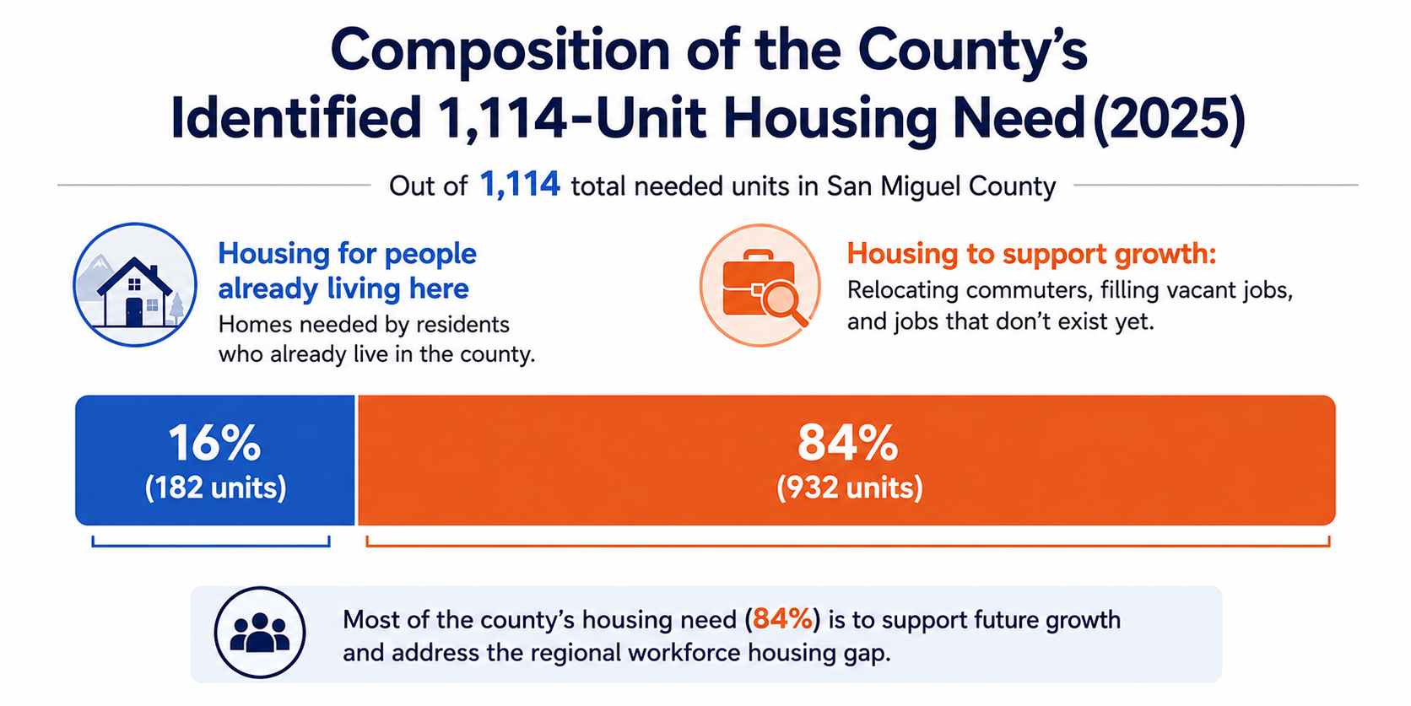
Exhibit 1. Components of the 1,114-unit need identified in the 2025 Housing Needs Analysis.⁴⁷
This report adopts the first objective as its analytical lens: house the current workforce; do not subsidize growth through the housing program. The choice rests on three findings developed in the sections that follow: demonstrated demand is concentrated among existing workers at below-market price points (Section 5); the public cost of serving growth-driven demand is unbounded so long as the growth itself is unbounded (Sections 6 and 10); and the Region's shared infrastructure cannot absorb open-ended expansion (Section 9). A jurisdiction that elects the growth objective can do so — but the election should be explicit, made by its governing body with the associated infrastructure obligations stated, rather than implicit in the sizing of a housing program.
3. The regional housing framework
A renter in the Region encounters four distinct systems:
- Market-rate rentals. Unrestricted units; few listings at any time, with most turnover occurring through informal channels.
- Town of Telluride portfolio (251 units).¹ Shandoka (140 units), Sunnyside (30), Voodoo (27), Virginia Placer (21), and the Boarding House (33 rooms). Rents are set by household income tier rather than by unit.
- Village Court Apartments, Mountain Village (approximately 220 units). Ninety-five units carry state income covenants at 50–60% of AMI; standard rents run from $824 (studio) to $1,574 (three-bedroom).²
- Privately owned deed-restricted units. Owner-occupied or rented under recorded restrictions; sales occur through lotteries, and rental listings are rare — one countywide in July 2026.³
3.1 The Town rent formula
Since January 2025 the Town has set rent by income. The mechanics can be stated in one worked example. A two-person household earning $85,000 falls at 89% of the applicable AMI grid, placing it in Tier C. Tier C rent is derived from the 80%-of-AMI income level; for a one-bedroom at Shandoka this produces $1,395 per month.⁴ If documented income rises into a higher tier at renewal, rent steps up with it — the mechanism that produced the large renewal increases reported in 2025.
Two structural features are material to the findings. First, the formula applies 25% of the tier target income at Shandoka's original buildings and 27% elsewhere, rates the Town reduced from 27–30% effective January 2026 following the vacancy experience described in Section 5.⁵ Second, the lowest-cost buildings accept new tenants only in the lower tiers (Shandoka's original buildings: Tiers A–D). A middle-income household can enter the system only through the newer, higher-rent properties.⁶
4. Affordability analysis
Affordability begins with wages. Exhibit 2 compares the rent affordable at 30% of income¹¹ for average earners in the Region's principal occupations⁷ with the two best-documented rent benchmarks.^{9,10}
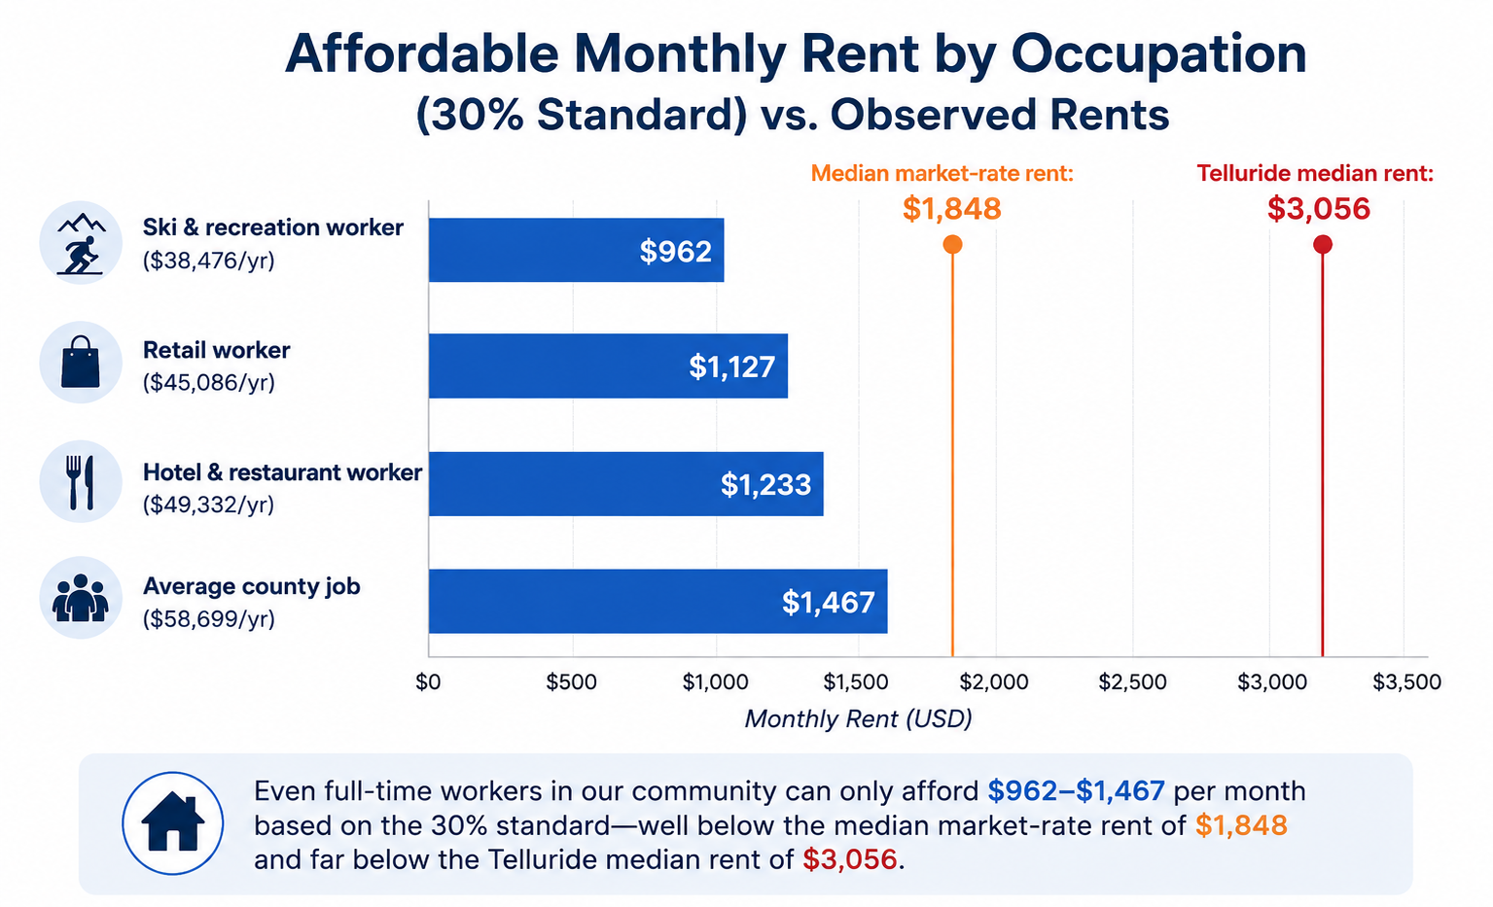
Exhibit 2. Wages: U.S. Bureau of Labor Statistics QCEW, San Miguel County, 2024 annual averages.⁷ Market median: 2024 regional household survey.⁹ Telluride median: U.S. Census ACS 2020–2024 (±$359).¹⁰
A single earner in the Region's two largest sectors — accommodation/food service (1,532 jobs) and ski/recreation (856 jobs)⁸ — cannot afford the median market rental without additional earners in the household. Census data extends the finding: more than half of county renter households pay over 30% of income in rent, and roughly one-third pay over half.¹²
Implication. The affordability gap is structural, not marginal. It cannot be closed from the wage side by any plausible single-employer action, which places the policy weight on the price, size, and quantity of restricted housing.
5. Demand analysis
None of the three governments maintains systematic vacancy, waitlist, or application records.¹³ The demand evidence therefore rests on discrete public events — which are, however, unusually informative, because they occurred at three distinct price points.
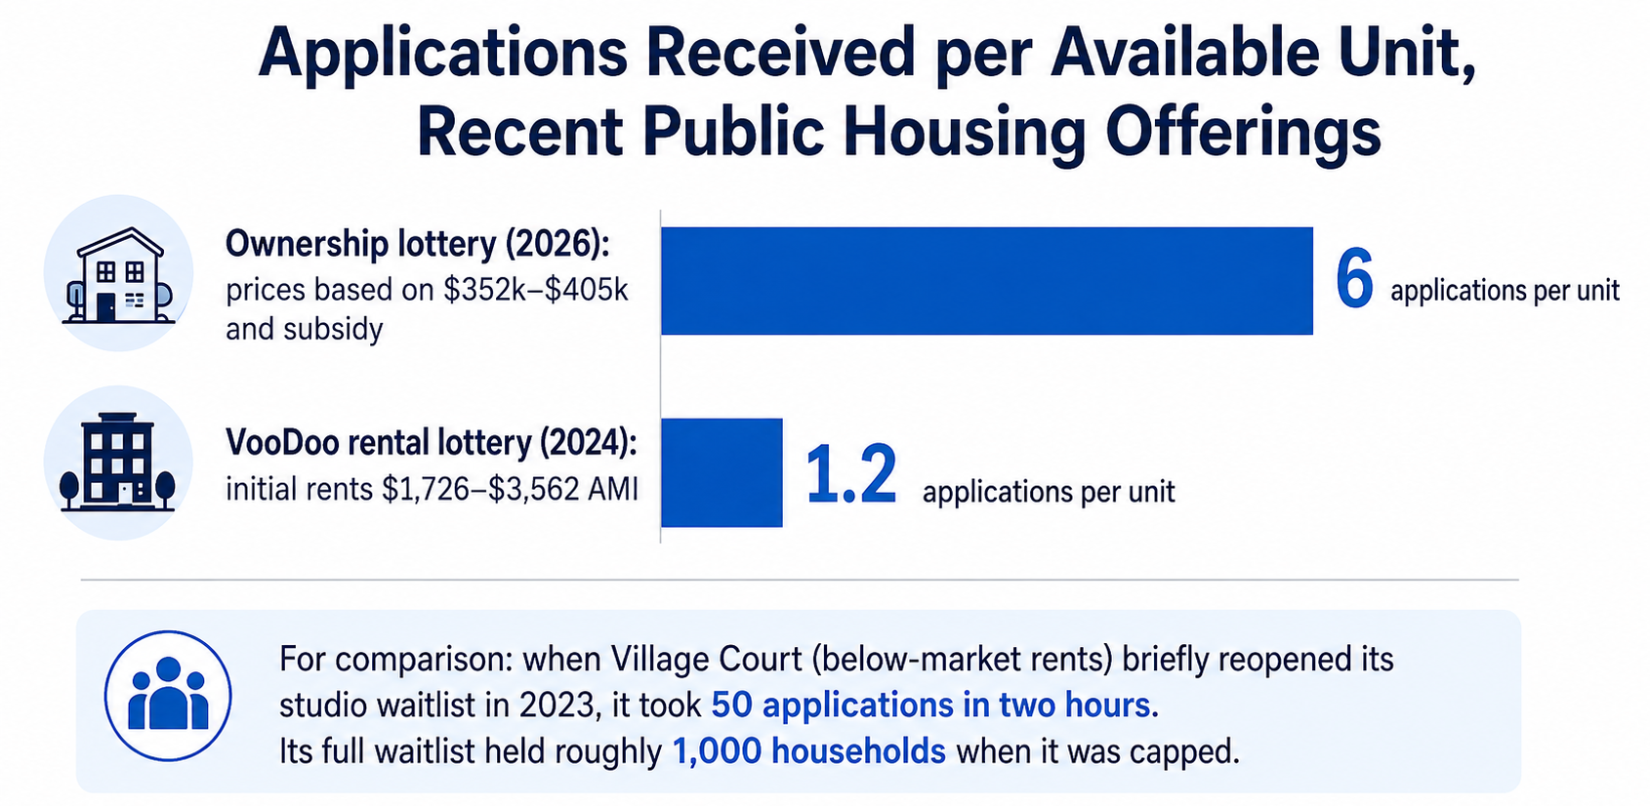
Exhibit 3. Voodoo: Town lottery records, August 2024.¹⁷ Ownership lottery: SMRHA certified results, April 2026.¹⁶ Village Court comparison: MVHA records.^{14,15}
The pattern is consistent: demand is deep at below-market price points and nearly exhausted at the 110–170% AMI rents at which the newest public supply was introduced.¹⁹ The December 2024 disposition of the Voodoo project's final five units — eligibility requirements reduced and units offered first-come, first-served — confirms the finding from the Town's own records.¹⁸
5.1 The January 2025 rent conversion
The Town's conversion of its 251-unit portfolio to income-based rents in January 2025 produced a natural experiment in price sensitivity:
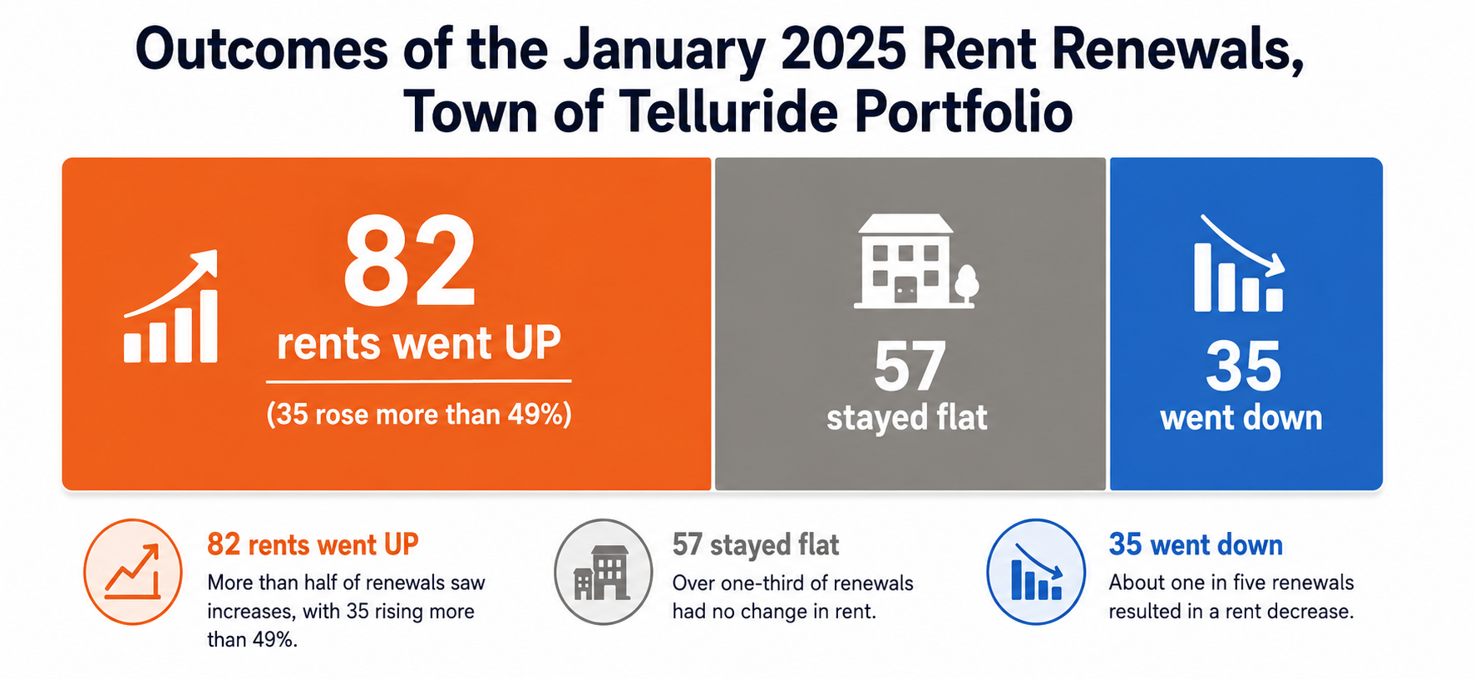
Exhibit 4. Renewal outcomes as reported April 2026.²⁰
By April 2026, 49 of 201 units stood vacant (approximately 24%), roughly 15 of them held for renovation.²¹ The Town's housing director stated publicly that the vacancies arose “not because of a lack of demand.”²² The Town Council subsequently reduced the rent multipliers effective January 2026, with projected tenant savings of $100–$400 per month.²³
Implication. The Region's shortage is specifically of housing priced at or below approximately 100% of AMI, concentrated in smaller units. Demand for product priced above approximately 120% of AMI has been tested twice by the market and found thin.
5.2 Two ownership experiments confirm the design rules
The Region has now run its ownership experiment in both directions. Meadowlark in Mountain Village (29 for-sale units, completed October 2024) sold 28 of 29 units within two months.⁵⁶ Its deed restriction has no income limits — only a Telluride R-1 employment requirement and a 4% annual appreciation cap — so the buyer pool was every worker in the school district.⁵⁷
Pinion Park in Norwood (24 homes, a Rural Homes pilot) shows the opposite outcome: five homes listed at $262,895–$383,244 have sat unsold for five to twenty months, and the housing authority has received exactly one qualification application.^{58,59} The covenants cap buyer incomes at 120% of AMI (80% on some units) while the prices require incomes near those caps — what a county commissioner called the search for a “unicorn buyer.” The original sales worked only because first buyers received a one-time 2.5%, no-down-payment mortgage product that resale buyers cannot get: the affordability lived in the financing, not the price.
Implication. Eligibility design determines whether units sell, independent of price. Employment-based restrictions with wide income windows work; income-capped ownership at prices near the cap fails; and affordability that depends on a subsidized mortgage product is fragile at every resale.
5.3 Sizing the need-catching target
Under the Section 2 lens, the program target is finite and can be stated from the record: the approximately 182 units of documented existing-resident need,⁴⁷ plus the share of current in-commuters the Region elects to repatriate (a policy tranche of roughly 100–200 beds, to be refined by the demand survey of Recommendation R7), less the beds recoverable by repricing the existing vacant public stock (approximately 70). The result is a program on the order of 250–400 beds, published annually with a defined end state.⁷⁹ This is the number the balance of this report is designed to deliver at the lowest public cost.
6. Cost of delivery
A below-market rent is not inexpensive housing; it is expensive housing in which the public pays the difference. The measure used here is straightforward: the share of a unit's delivery cost that its rent stream can finance, with the remainder constituting the public subsidy.²⁴
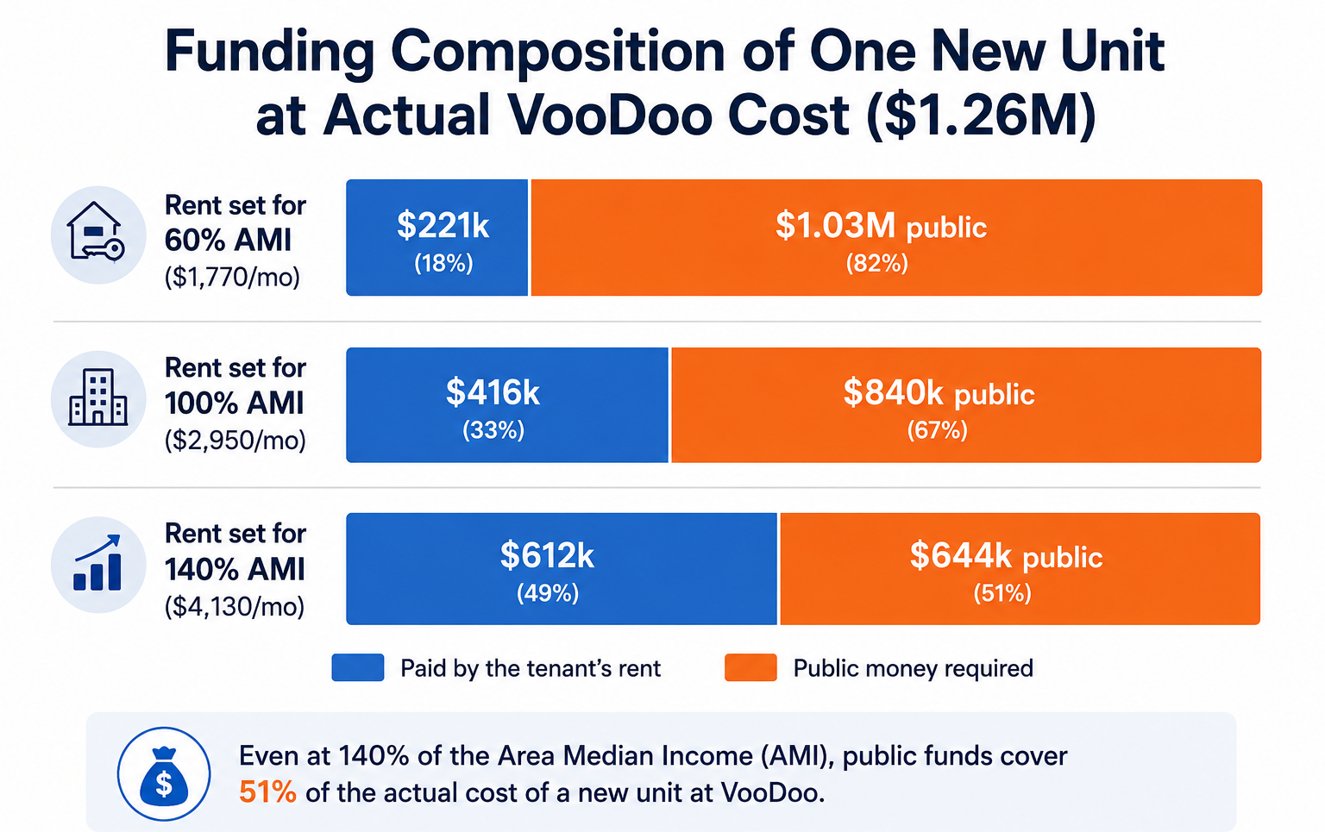
Exhibit 5. Livable Telluride analysis at VooDoo's actual delivery cost and financing terms; 30-year amortization is assumed, which is favorable relative to the actual balloon structure.^{24,26}
The project's first full year of operation confirms the model's direction. In fiscal 2025, Voodoo collected $872,000 in actual rent against $1,324,338 in debt service and operating costs — an annual funding requirement of approximately $452,000, with rents covering 73 cents of each dollar of debt service. Town budget documents describe the building as fully occupied for the year, although five of its 27 units remained unleased as of mid-December 2024, so early-2025 lease-up vacancy may depress the collected figure. The distinction does not change the conclusion: even at the project's full-occupancy revenue potential of roughly $0.9 million, rents cannot cover its costs — the shortfall is structural. The bonds do not amortize; a $23.05 million balloon falls due in December 2032, and no sinking fund is identified in published budgets. On that structure, the project's cumulative cost reaches approximately $41 million by 2032.²⁵
The delivery-cost comparison across the Town's two completed projects isolates the controlling variable — construction cost:
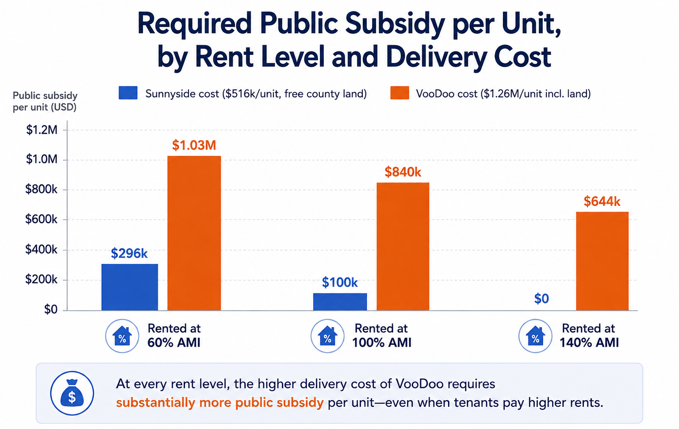
Exhibit 6. Same method, both completed projects.^{24,27} The proposed Shandoka Lot L program (approximately $3.3M per unit) is excluded because its cost includes an approximately 900-space parking garage.²⁸
Ongoing costs continue for the life of the asset. Benchmarked against the closest mature comparator (Whistler Housing Authority audited statements) and the Town's own actuals, steady-state operations for the 251-unit portfolio approximate $3.3 million per year before reserves;²⁹ an age-appropriate capital reserve adds $600,000 to $1 million per year;³⁰ scheduled balloon maturities total $23.05 million (2032) and $6.17 million (by 2040);³¹ and the Town's housing operation already carries a $13.76 million annual budget with more than ten staff.³² Administration at program maturity, on the Aspen and Whistler evidence, approximates $2,000–$3,000 per unit per year and does not sunset.³³
6.1 Delivery models compared
The Region has now tested six delivery models. Ranked by net public cost per unit or restriction:
- Restriction purchase (Vail InDEED): ~$62,000–$68,000. Proven at 162 units; limited by willing sellers.³⁴
- Meadowlark ownership: ~$137,000 per unit (~$61,000 per bedroom). 29 units; $20.9M budget, ~$6M town contribution less $1.6M+ recovered from unsubsidized sales to essential organizations; sold out.⁵⁷
- Village Court Phase 4 rental: ~$4M town cash on $22.6M (35 units, 88 bedrooms; the balance carried by a $15M lease-purchase and $3M+ in grants).⁵⁷
- Sunnyside rental: ~$300,000–$500,000 class (free county land).²⁷
- VooDoo rental: ~$955,000 all-in public cost per unit, with the ongoing shortfall documented above.²⁵
- Shandoka Lot L proposal: ~$3.3 million per unit, garage-burdened.²⁸
Two design lessons run through the list. First, land cost and construction cost — not operating choices — set the subsidy; projects on free or town-owned land at modest specifications (Meadowlark, Sunnyside) cost the public a fraction of bespoke in-town construction. Second, density spreads the subsidy: Mountain Village's own council concluded it should have built 41 units at Meadowlark rather than 29.⁵⁷
Implication. At current delivery costs, each new below-market unit is a $0.6–$1.0+ million public commitment before its share of regional infrastructure. The restriction-purchase alternative — approximately $62,000–$68,000 per unit in Vail's program³⁴ — warrants evaluation as the first use of each housing dollar wherever eligible inventory exists.
7. The return per worker housed
Cost is half of the appraisal; the other half is what a bed returns. Under the need-catching lens, each proposed bed should first pass a threshold test: does it change who fills an existing job, or does it enable a new one? A bed that moves a commuting or overcrowded worker into stable housing adds essentially no new demand to the Region — the job already exists, the worker's consumption already occurs here, and independently measured home-service employment places workforce households at the bottom of the generation curve (approximately 0.01–0.1 FTE per modest local unit, against roughly one FTE for a large, lightly used second home).⁷⁶ A bed that permits a new enterprise to staff up serves the growth objective and should be evaluated under Section 2's election, with its infrastructure obligations stated.
The measurable annual return of housing one existing worker locally comprises: avoided commuting cost (approximately $18,000–$20,000 per year in vehicle costs for a Montrose commuter at standard mileage rates); recovered travel time (approximately 2.5 hours per day); employer turnover and vacancy savings; reduced peak-hour load on the failing gateway intersections; and local participation effects (school enrollment, emergency service volunteers). Stated conservatively, the combined return approximates $25,000–$40,000 per worker per year.⁷⁷ This figure functions as the appraisal yardstick: an instrument whose annualized public cost per bed exceeds it makes the community worse off with each bed it fills.
8. The efficiency frontier
Ranking the Region's demonstrated instruments by net public cost per worker housed per year, against the Section 7 return, produces the following order:⁷⁸

Instrument | Public cost per bed | Annualized | Induced growth | Return vs cost
1. Reprice the ~49 vacant town units | ~$0 capital | ~$2–4k/yr | None — units exist | ~10 : 1
2. Purchase deed restrictions | ~$30–35k one-time | ~$2k/yr | None — no construction | ~10 : 1
3. Master-lease existing market units | Ongoing | ~$5–15k/yr | None; reversible | 2–5 : 1
4. Meadowlark-class ownership, public land | ~$61k/bedroom | ~$4k/yr | Limited | ~5 : 1
5. VCA-4-class modest rental, free land | ~$45k cash/bedroom | ~$5k/yr | Limited | ~4 : 1
— break-even threshold —
Voodoo-class bespoke construction | ~$700k+/bed | ~$45k+/yr | Full | Below 1 : 1
Lot L-class (garage-burdened) | ~$1.5M+/bed | ~$100k/yr | Full | Far below 1 : 1

Two observations organize the table. First, the top three instruments house the identical worker at roughly 5–20% of construction cost, with no draw on the wastewater plant, the road network, or the construction labor market; under the need-catching lens they are not merely less expensive — they are the only instruments fully consistent with the lens, because they operate within the existing building stock. Second, below the break-even threshold, the annualized public cost of a bed exceeds the entire measurable annual benefit of housing the worker in it (F9). The Region's largest recent investment was made below its own break-even line, which is why the housing budget has grown while the measured deficit has not closed.
9. Infrastructure capacity assessment
Each additional household draws on four shared systems. Their status, from their own engineering and regulatory records:
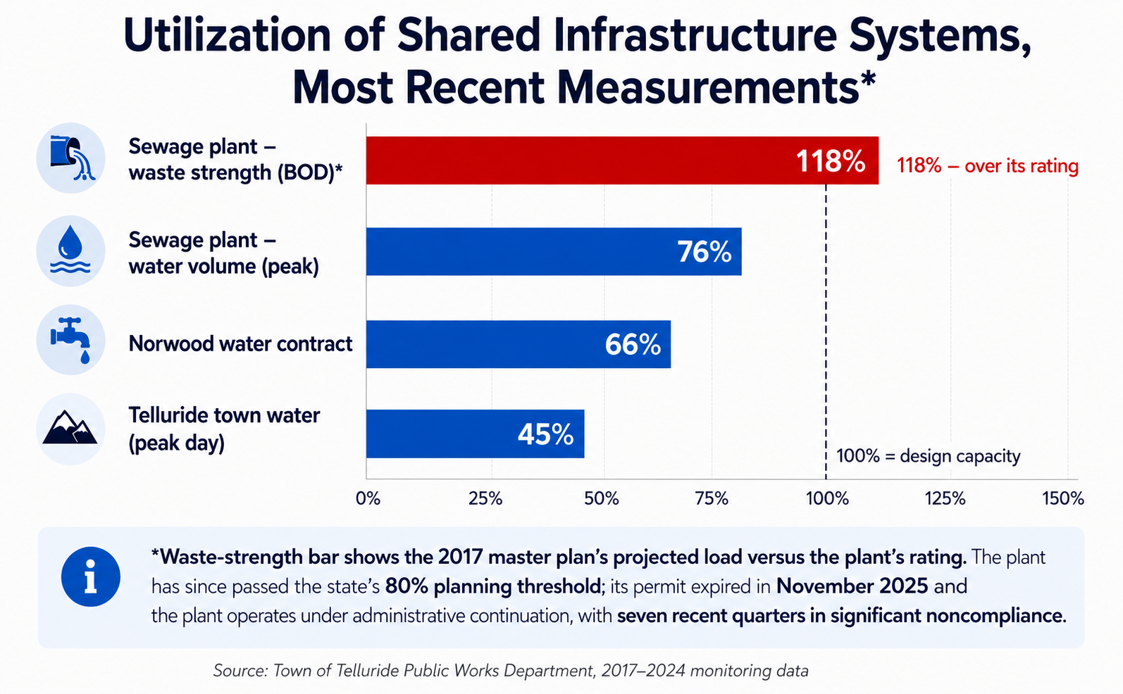
Exhibit 7. Wastewater: 2017 master plan, EPA compliance records, 2025 Town records.³⁵ Norwood: SGM engineering studies.⁴² Telluride water: Town Water Efficiency Plan.⁴¹
9.1 Wastewater
The regional treatment plant serving Telluride, Mountain Village, and adjacent communities is constrained by waste strength rather than flow. It has passed the State's 80% capacity planning trigger; its discharge permit expired in November 2025 and remains in administrative status; and federal compliance records show significant noncompliance in seven of the last thirteen quarters.³⁵ A 2024 attempt to expand the existing plant was canceled when thirty-percent design pricing exceeded $133 million for approximately 0.2 MGD of additional capacity.³⁶ The governments have since executed a memorandum of understanding for a new 2.67 MGD regional facility near Ilium, with a new Sewer Authority required by July 1, 2028; its cost has not been published.³⁷
The deeper constraint is the site itself. The existing plant occupies a 3.24-acre parcel with only about 2.5 usable acres — “restricted expansion space” appears on the towns' own list of challenges — and the rejected retrofit would have bought capacity only through 2047 while rebuilding around a live plant.⁶¹
9.2 From gallons to people: how the plant caps growth
Wastewater capacity is the one regional limit that converts directly into a population number, so it is worth showing the arithmetic. Treatment plants are sized two ways: by water volume (millions of gallons per day, MGD) and by waste strength (pounds of BOD per day). In standard planning, each person present in the service area — resident or visitor — contributes roughly 70 to 100 gallons per day once household, lodging, restaurant, and commercial flows are averaged in. A hotel pillow counts like a resident; a restaurant seat or brewery adds waste that is several times household strength per gallon, which is why this plant hit its strength limit first.⁶⁰
Apply the conversion. The existing plant's 2.1 MGD rating corresponds to roughly 21,000–30,000 people present at peak — and the towns report festivals push up to 24,000 visitors onto the system on top of residents, which is precisely when the plant strains.⁶¹ The new regional plant is planned at 2.67 MGD: about 27% more volume. Against current peak flows (~1.6 MGD), that is roughly 1.0–1.1 MGD of headroom — room for perhaps 10,000–15,000 additional people present at peak, across every use and every jurisdiction the plant serves, for the next generation.⁶²
Now subtract what is already committed: two five-star hotel projects, the Society Turn program (up to 125 rooms, a hospital, and ~188,000 sq ft of commercial space), 70–100 rental units planned at Ilium, and 121 employee-housing units at Society Turn — all draw from that same headroom before any future proposal is considered. The Sewer Authority's plant-sizing decision, due by July 1, 2028, is therefore not an engineering detail. It is the Region's carrying-capacity decision — the one number that will actually function as a growth ceiling for thirty years — and it deserves to be debated as exactly that.
9.3 Transportation
Within town, the Davis Street/Colorado Avenue intersection already operates at LOS F in peak periods (174-second average delays, deteriorating).³⁸ Regionally, the two intersections connecting the East End to the highway network — the Society Turn roundabout and Last Dollar Road/SH 145 — are projected to fail under background traffic growth alone within the planning horizon; a single large development advances the failure to the current decade, and mitigating either node transfers load to the other.³⁹
9.4 The gondola
The gondola has connected Telluride and Mountain Village since 1996, free to ride, and it is approaching the end of its service life. The agreements that operate and fund it expire December 31, 2027, and replacement is estimated at $120–150 million.⁴⁰
In November 2024, voters within the SMART transit district approved Ballot Issue 3A — a new sales tax and mill-levy increase to fund gondola capital improvements and its operation and maintenance — by 1,956 votes to 1,758. The measure's required TABOR notice projected $8.2 million of revenue in 2025, an increase of $5.2 million over what the district expected without it.⁷⁰ That is the arithmetic Exhibit 8 shows: the dedicated stream covers roughly 5–7% of the replacement estimate each year, and simply accumulating $120–150 million at $8.2 million per year would take 15–18 years — before counting the operations and maintenance the same fund must also pay for.
The funding stream is also under legal challenge. An election contest argued that the ballot language and TABOR notice were misleading about what voters were being asked to fund; the district court dismissed the contest in August 2025, holding the language was not clearly misleading, and the case is now before the Colorado Court of Appeals, with briefing completed in July 2026 and a decision pending as of this report.⁷¹ Until it resolves, the Region's only dedicated replacement funding rests on an election decided by 198 votes and a pending appellate ruling — and no contingency funding plan has been published.
Planning continues in parallel. Under the Third Supplement to the 2023 cost-sharing agreement, effective January 1, 2026, the gondola partners — SMART, both towns, San Miguel County, TSG Ski & Golf, and the Mountain Village Owners Association — adopted a $2.46 million development budget for 2026, half carried by SMART and one quarter each by Telluride and the Mountain Village entities, most of it for project-development services.⁷² The project as currently envisioned runs six stations, from Oak Street in downtown Telluride to the Mountain Village Center, and SMART issued a request for proposals for a structural condition assessment of the existing system in April 2026.⁶⁹ For carrying-capacity purposes the gondola behaves exactly like the sewer plant: a fixed, growth-driven capital item whose replacement bill arrives on its own schedule, and whose funding is at present neither sufficient nor certain.
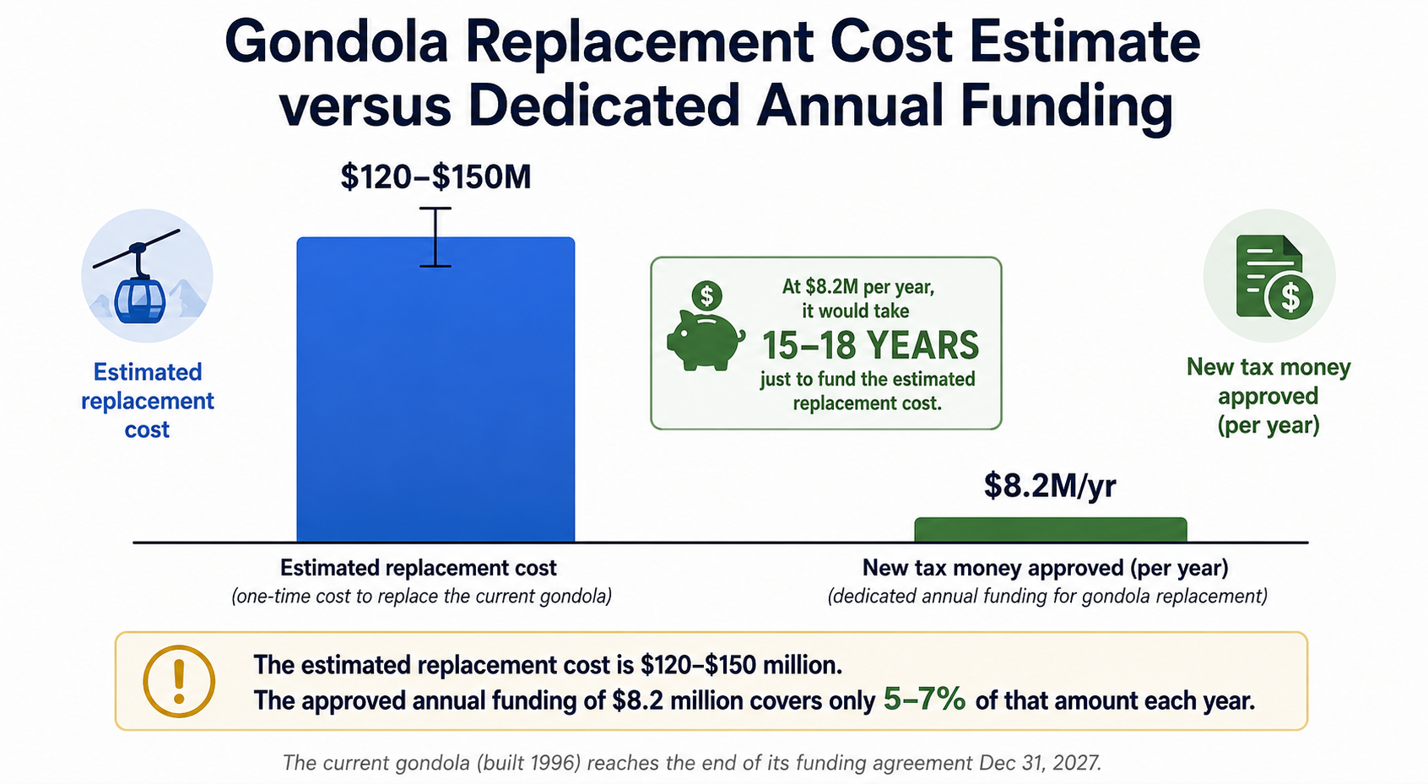
Exhibit 8. SMART district records and cost-sharing agreements; the current operating agreement expires December 31, 2027.⁴⁰
9.5 Water
The Town of Telluride's water system is the one system with substantial headroom: peak-day demand of 0.90 MGD against approximately 2.0 MGD of treatment capacity, with a designed expansion path.⁴¹ Norwood presents the opposite case: its firm supply is a single 300 acre-foot contract, approximately two-thirds committed, projected to be fully consumed between 2036 and 2042; its treatment plant approaches capacity on the same horizon.⁴² Proposals to relocate workforce housing demand to the West End draw on this fixed supply.
9.6 Evacuation
Telluride occupies a box canyon with a single road connection. The County's adopted 2023 hazard mitigation plan describes wildfire evacuation as “a huge concern,” notes that festival populations triple evacuation demand, and lists a secondary egress road for Mountain Village among its official mitigation actions.⁴³ No evacuation clearance-time analysis exists for the canyon at any population level. Peer precedent demonstrates both the feasibility and the durability of such analysis: Sanibel, Florida grounded its adopted build-out limit in hurricane evacuation clearance time, and that framework withstood legal challenge.⁴⁴
10. Growth dynamics
Workforce housing interacts with growth through a well-documented cycle: housed workers enable expanded commerce, which creates additional employment and generates additional housing need. Resort-economy studies estimate the service-employment overhead at approximately 15–35% per housed household — a convergent feedback, independently reproduced by Livable Telluride's closed-loop model of measured home-service employment and resident spending, which yields a housing-need multiplier of 1.10–1.35.^{45,76} The dynamic is embedded in local regulation: the Town's own code attributes 2.5 jobs to every 1,000 square feet of new commercial space and requires mitigation of 40% of them, so that each approval adds unhoused workers by design.⁴⁶
Peer experience over five decades spans the range of possible outcomes. Aspen/Pitkin County built the largest program in the United States (more than 3,100 units) without limiting growth and continues to import about 7,500 workers daily.⁴⁸ Whistler capped total resort capacity first and built housing toward a fixed target; it houses 84% of its workforce locally, the strongest result in the industry.⁴⁹ Big Sky, Montana, built no comparable program and imports about 80% of its workforce by highway.⁵⁰
10.1 The pipeline already in motion
Growth accommodation is not hypothetical here; it is under construction. Four Seasons Telluride (Mountain Village): 26 private residences priced from $4 million plus 43 hotel residences, with five-star service levels and no on-site employee housing identified in its materials.⁶³ Six Senses 109R (Village Center): 50 guaranteed hot-bed lodge units, 31 lodge units, 20 condominiums, and ~26,000 sq ft of commercial space, with 20 on-site employee units, 18 of them dormitories of 306–408 sq ft.⁶⁴ Society Turn (approved; road work underway): up to 125 hotel rooms, ~188,000 sq ft of commercial, office, and flex space, a future acute-care hospital, and 91–121 employee-housing units.⁶⁵
At customary luxury staffing ratios, the two hotels alone imply on the order of 200–400 new service jobs against on-site housing for perhaps 25–40 workers.⁶⁶ Each project was sized against its own traffic and utility study, while the corridor studies show the gateway intersections failing on background growth alone — individually defensible conclusions that are collectively impossible. No cumulative ledger exists to see the sum; that is the gap Recommendation R2 closes.
10.2 The bill one jurisdiction sends the others: a worked example
The two Mountain Village hotels make the externality measurable, because neither Telluride nor the County had any authority over their approval — yet most of the housing, road, and sewer consequences land region-wide. The method is a five-link chain: jobs created, converted to workers (resort workers hold about 1.2 jobs each), converted to households (1.4–1.8 workers per household), less the workers housed on-site, times the public capital the Region actually spends per below-market unit.⁷³
Applied to the two projects: 200–400 new service jobs become roughly 70–220 unhoused worker households — centrally, about 140 — after crediting the only on-site housing either project provides. These are service wages, mostly 60–100% of AMI: the tier where demand is deepest and where the Region's demonstrated public gap runs $145,000–$352,000 per unit at Sunnyside-class delivery and $678,000–$1,090,000 at VooDoo-class delivery. The resulting public housing bill is roughly $55–100 million centrally, with honest bounds from $10 million to $240 million.⁷⁴
Divided by the roughly 124 hotel keys, that is $450,000–$800,000 of unfunded public housing obligation embedded in every luxury key — about $200,000–$360,000 per guest pillow. The same two projects draw down the shared systems directly: roughly 0.05–0.08 MGD of wastewater demand — about 5–8% of the new regional plant's entire generational headroom — and several hundred daily vehicle trips against the failing Society Turn intersection pair.⁷⁵
The point is not that these projects are improper; it is that the bill exists whether or not anyone writes it down. A standing, one-page project housing and infrastructure bill — jobs by wage tier, net unhoused households, public capital at demonstrated delivery costs, MGD and peak trips — published for every approval region-wide, would have put these numbers in front of every affected government before the decisions were made. The estimates above are ranges [E] and should be replaced by the projects' mitigation filings when those become public, including any credit due under Mountain Village's own mitigation code.
Implication. Housing sized to the documented needs of existing residents and current workers remedies a deficit. Housing beyond that point, or priced to recruit new higher-income households, accommodates growth — and its infrastructure costs (Section 9) arrive with it. Until the Region adopts an explicit target for the scale of its visitor economy, the distinction cannot be enforced.
10.3 Managing the committed influx: a least-cost response plan
The two hotels are approved and under construction; the estimated 70–220 worker households of Section 10.2 will arrive on the operators' schedule whether or not the Region prepares. This is the one growth event the need-catching lens cannot screen out — the election was made, by one jurisdiction — so the question becomes narrow and practical: how to absorb a known influx at the least public cost and the least impact on the existing community. Five measures, in order of leverage:
1. Assign the bill to its owners. Luxury operators budget for staff housing in every comparable market, and the Region's remaining points of discretion — final certificates of occupancy, license approvals, any future amendment either project requests — are its negotiating opportunities. The objective is executed agreements before opening: operator-funded housing commitments sized to actual staffing plans, with the mitigation filings (Section 17) replacing the estimates of Section 10.2. Every worker housed at operator expense is a worker the public never pays for.⁸²
2. Master leases before mortar. The fastest instrument that matches a staffing ramp is the master lease: the operators (or the housing authority, funded by them) lease blocks of existing units regionally — at approximately $5,000–15,000 per bed per year, roughly 140 households can be absorbed for $0.7–2.1 million annually, a minor operating line for two five-star properties and a rounding error against the $55–100 million public construction alternative. Master leases are reversible if staffing falls short, draw no infrastructure, and begin working the month they are signed.⁷⁸
3. On-site and near-site seasonal capacity. Six Senses' 18 dormitories are the honest product for seasonal service staffing and the template to extend: additional dormitory capacity on operator-controlled land in Mountain Village houses peak-season staff where they work, off the highway network entirely. The Region's role is permissive speed, not funding.
4. Transit as the partial substitute for beds. A share of the workforce will live down-valley and in Montrose regardless of policy; the community-impact variable is whether they arrive in single-occupancy vehicles through the failing gateway intersections. Employer-funded, shift-timed service — the Section 11.2 package: late-evening returns, guaranteed ride home, universal passes, park-and-rides at Placerville and Norwood, vanpool coordination — costs approximately $2,000–5,000 per worker per year, one-tenth the annualized cost of a constructed bed, and directly reduces peak-hour load.⁷⁷
5. Sequence the corridor beds already entitled. The 121 Society Turn employee units and the 70–100 planned at Ilium/Alexander are the constructed capacity nearest the new jobs, outside the box canyon, adjacent to the future treatment plant. The Region's task is timing and pricing: completion covenants aligned to hotel openings, rents set to service wages (60–100% of AMI, per Rule 6), and operator master-lease commitments that guarantee absorption without public carrying risk.
What the response plan avoids is equally specific: no public bespoke construction undertaken in the hotels' name (a second Voodoo, justified by the influx, would compound the original externality with a below-break-even response); no discounted mitigation buyouts against stale fee schedules; and no expansion of the general housing program on the hotels' account — the influx is the operators' bill, and the framework's function is to keep it on their ledger. Managed this way, the public exposure of a $55–100 million externality contracts to roughly $5–15 million of targeted restriction purchases, transit capital, and administration — with the balance carried where it originated.⁸²
11. Carrying-capacity synthesis and siting
Regional carrying capacity is the most binding of the individual limits. On the assembled record:
- Land. Of the approximately 20,250-acre East End planning area, 476 acres carry multifamily-capable designations and are substantially built out; the remaining acreage is zoned at one unit per 35 acres. Additional multifamily capacity is therefore a policy decision (rezoning or public land), not an existing entitlement.⁵¹
- Wastewater. At the constraint now; relief requires a nine-figure facility and a new regional authority by 2028.
- Transportation. Gateway intersections fail within the planning horizon on background growth alone.
- Water. Adequate in Telluride; approaching exhaustion in Norwood.
- Evacuation. Unquantified.
Colorado law forecloses the bluntest instrument — annual residential permit caps.⁵² The legally durable framework, demonstrated by peer communities, combines: a published parcel-level buildout ledger (Teton County model⁵³); a per-capita infrastructure accounting unit (Whistler's bed-unit⁵⁴); adopted infrastructure thresholds that trigger review; and, most defensibly, a safety-based limit grounded in evacuation clearance time (Sanibel model⁴⁴).
Count pillows, not just units. Most of the committed pipeline is visitor beds, which consume sewer capacity, road capacity, gondola trips, and evacuation time exactly as housing does — yet appear nowhere in the housing debate. This is why Whistler's ledger counts bed-units rather than dwellings, and why the evacuation study of Recommendation R1 must be run at festival-plus-hotel peak population, not resident population.
11.1 Where new housing should go
The constraints, read together, draw a map. The Highway 145 corridor — Ilium/Alexander and Society Turn — is the Region's rational growth shelf: Community Housing zoning is in place at Alexander, the land is publicly owned (the variable that made Meadowlark cheap), the new wastewater plant will sit next door, the sites lie outside the box canyon (evacuation-neutral), and the 63L intersection work is already under study. Society Turn's 121 employee units add a second node beside the hospital and hotel jobs. Inside Telluride proper, purchase restrictions instead of building — delivery costs of $1.26M–$3.3M per unit and an unquantified evacuation envelope argue against major in-town construction. The West End stays conditional until Norwood's water is solved (Section 11.2). Montrose remains the safety valve, understood honestly as a commuting mandate.
One sequencing rule keeps the strategy honest: corridor concentration loads the same intersections the studies say are failing. Infrastructure and the capacity ledger come first; entitlements draw against them, not ahead of them.
11.2 The Norwood option: water first, then transit
Norwood is the Region's only large supply of inexpensive, developable land — and its water system is committed to roughly two-thirds of a single 300 acre-foot contract. The instinctive fix, transferring Telluride water rights to Norwood, is mostly the wrong instrument: Norwood already owns a decreed 5 cfs San Miguel River diversion right it has never built. Its constraint is not paper water but infrastructure — the intake, the pump lift from the canyon to Wright's Mesa, a transmission line, and a treatment plant already nearing capacity.⁶⁷
Where Telluride's water genuinely helps is dry-year firming: Norwood's river right is junior and could be curtailed in drought — exactly when its reservoir supply is weakest — while Telluride holds senior stored water (Blue Lake, 1,300+ acre-feet) upstream of Norwood's diversion point. A commitment of storage releases in curtailment years would firm the river right at little cost to Telluride in normal years. The workable structure is a water-for-housing intergovernmental agreement, analogous to the 2025 wastewater MOU: the governments co-fund the diversion package, Telluride provides the firming commitment, and Norwood commits a defined share of the unlocked capacity to workforce housing with Meadowlark-style eligibility — not the income-capped design that stranded Pinion Park.⁶⁸
If the water works, the road must too. SMART already runs a Norwood–Telluride commuter bus — about 65–70 minutes, $2 each way — that is lightly used.⁶⁹ The fixes are known transit practice, and inexpensive next to construction subsidies: schedules built around hospitality shifts (including late-evening returns, the gap that forces workers to drive), a guaranteed-ride-home policy, universal employer-paid passes, park-and-rides at Norwood and Placerville, winter-reliable equipment for Norwood Hill, an on-demand feeder within Wright's Mesa, and onboard Wi-Fi that converts the ride into usable time. The accounting rule from Section 6 applies here as well: the per-rider transit subsidy belongs inside the cost-per-worker-housed comparison, where even generous service costs a fraction of a $1 million construction subsidy.
12. The decision framework
The following ten rules convert the assembled evidence into an objective evaluation method. They are designed to be applied in order, in public session, to every proposal that requests public funds, public land, a density bonus, or a fee waiver for housing.
Rule 1 — State the objective before the project.
Every proposal identifies, in its opening section, whether it houses the current workforce or accommodates growth. Growth accommodation is a legitimate elected choice — made by the governing body, with the associated infrastructure obligations stated — not a default embedded in a housing program (Section 2).
Rule 2 — Count first, build last.
The program target is the documented existing deficit plus the adopted commuter-repatriation tranche, published annually with an end state (Section 5.3). No project is approved against projected need. When the target is met, the program transitions to maintenance mode.
Rule 3 — House existing jobs, not future ones.
Eligibility requires current employment in the R-1 district with a tenure requirement. Priority order: overcrowded and displaced residents first, current in-commuters second. Each bed must change who fills an existing job (Section 7).
Rule 4 — Exhaust the frontier in order.
Reprice vacant public stock; purchase restrictions while sellers exist; master-lease the flexible margin; construct modest units on public land only for the measured residual (Section 8). A proposal to construct is simultaneously a representation that every less expensive instrument is exhausted; the record should demonstrate it.
Rule 5 — Maintain the break-even test.
The measurable return of housing one worker is $25,000–$40,000 per year (Section 7). Annualized all-in public cost per bed must remain below it — in practice, a capital ceiling of approximately $300,000–$450,000 per bed, and realistically the free-land, modest-specification delivery class. Instruments above the line reduce community welfare with each bed filled.
Rule 6 — Price to demonstrated demand.
New below-market product is priced at or below the approximately 100%-AMI equivalent, where the documented queues are. Product above approximately 120% of AMI has twice been tested by the market and found to have near-zero excess demand (Section 5); delivering it converts public capital into vacancy.
Rule 7 — Use wide eligibility windows.
Ownership restrictions follow the Meadowlark design — employment-based, with appreciation caps and no income limits or wide ones. Income caps set near the qualifying price manufacture the “unicorn buyer” and strand the inventory, as documented at Pinion Park (Section 5.2).
Rule 8 — Prioritize instruments with zero infrastructure draw.
Where two instruments can house the same worker, the one that draws no wastewater, road, or evacuation capacity ranks first. Construction proposals state their gallons-per-day and peak-trip draw against the published regional headroom (Section 9.2).
Rule 9 — Maintain separation from commercial mitigation.
Beds created with public funds are not credited against commercial mitigation requirements and do not unlock additional commercial floor area. Permitting that channel converts workforce housing into growth accommodation and defeats Rule 1.
Rule 10 — Publish occupancy monthly; sunset what stops filling.
Vacancy, waitlist, and application counts by property, unit size, and tier, published monthly. Any tier vacant more than 90 days triggers a repricing review. Instruments are selected for reversibility where possible, because a need-catching program is designed to conclude.
Conditions warranting rejection
The following features, on the assembled record, are sufficient grounds to return a proposal without further analysis:
- Bespoke in-town construction above approximately $500,000 per unit — below break-even before opening (F9).
- Justification based on projected job growth — a growth-objective proposal, to be evaluated under Rule 1's election.
- Income caps within reach of the qualifying price — the documented Pinion Park failure mode.
- Rental product priced above approximately 120% of AMI — twice-demonstrated absence of demand.
- Structured parking within a housing pro forma — the Lot L pattern; parking is a transportation investment and should be appraised as one.
- Perpetual subsidy structures for seasonal or cyclical needs — master leases exist for this purpose and can conclude.
- Demand evidence consisting solely of consultant projections — the Region possesses actual queues; proposals should cite them.
13. Proposal evaluation scorecard
A single page, applied in public session to every proposal requesting public funds, land, density, or waivers. Eight affirmative answers are required to proceed; any Section 12 rejection condition concludes the evaluation regardless of score.

# | Question | Answer
1 | Does the proposal state its objective — and is it need-catching (Rule 1)? | Yes / No
2 | Does it count against the published deficit rather than a projection (Rule 2)? | Yes / No
3 | Will every bed house a current R-1 worker under tenure eligibility (Rule 3)? | Yes / No
4 | Is each less expensive frontier instrument demonstrably exhausted (Rule 4)? | Yes / No
5 | Is annualized public cost per bed below the $25–40k/yr return (Rule 5)? | Yes / No
6 | Are rents or prices at or below the ~100%-AMI equivalent (Rule 6)? | Yes / No
7 | Are eligibility windows employment-based and wide (Rule 7)? | Yes / No
8 | Is infrastructure draw zero, or stated and de minimis against headroom (Rule 8)? | Yes / No
9 | Is the proposal firewalled from commercial mitigation credit (Rule 9)? | Yes / No
10 | Does it include monthly occupancy reporting and a sunset trigger (Rule 10)? | Yes / No

14. Retrospective application
The framework is testable against the Region's own completed and proposed projects. Scored as the rules are written:⁸⁰

Project | Score | Framework result
Meadowlark (2024) | 9 of 10 | Public land, approximately $61,000 per bedroom, employment-based eligibility with no income limits; 28 of 29 units sold within two months. The single deficiency: no published occupancy/sunset regime. Mountain Village's council subsequently concluded 41 units would have out-performed 29 — density spreads the subsidy.
Village Court Phase 4 (2024) | 9 of 10 | Modest specification, free land, approximately $45,000 cash per bedroom, priced at the documented waitlist; waitlist turnover visibly improved. The template for the rental residual.
Pinion Park (2021–) | 5 of 10 | Correct objective and price point; failed eligibility design. Income caps near the qualifying price plus non-replicable first-buyer financing: five homes unsold five to twenty months, one qualification application. Rule 7 as written.
Voodoo (2023–24) | 3 of 10 | Fails Rule 5 (approximately $955,000 all-in per unit), Rule 6 (rents near 140% AMI produced 1.2 applicants per unit and December vacancies, with eligibility subsequently loosened), and Rule 10 (the vacancy accumulation proceeded unmeasured). The costliest entry in the ledger and the principal motivation for this framework.
Shandoka Lot L (proposed) | 1 of 10 | Approximately $3.3 million per unit including a 900-space garage: a transportation facility within a housing pro forma. Multiple rejection conditions apply.

15. Program plan, cost, and end state
Sized to Section 5.3 and delivered on the Section 8 frontier, the need-catching program is specific and affordable: recovery of the approximately 49 vacant town units through repricing (≈70 beds, no capital); 40–60 purchased restrictions as sellers appear (≈$3–4 million); a master-lease margin flexed to seasonal demand; and a constructed residual of 150–250 bedrooms at Meadowlark/VCA-class delivery costs (≈$7–15 million). The complete program approximates $15–25 million over a decade, with a defined end state.⁸¹
For scale: that is less than the all-in public cost of the single Voodoo project (approximately $26 million for 27 units), and a small fraction of the $120–150 million gondola replacement or the nine-figure wastewater program. The constraint on regional housing policy has not been money; it has been instrument selection — the highest-return instruments have remained largely unused while the lowest-return instrument absorbed the budget.
When the published deficit closes, the program concludes by design: leases sunset, construction stops, the restriction fund becomes opportunistic, and the occupancy dashboard becomes the early-warning system for the next cycle. Peer experience indicates this is the difference, measured over decades, between Whistler's outcome and Aspen's.^{48,49}
16. Recommendations

Ref | Recommendation | Responsible party
R1 | Commission an evacuation clearance-time study for the box canyon at current, festival-peak, and build-out populations. This is the gating capacity analysis; comparable studies cost $75,000–$150,000. | San Miguel County OEM with both Towns
R2 | Publish an annual capacity ledger: remaining zoned capacity by parcel, a bed-unit accounting, and measured status of the wastewater plant, gateway intersections, and regional water. Score each application against it. | County planning; adopted jointly by the Towns
R3 | Adopt a restriction-purchase-first test: before committing construction funds, price the deed-restriction purchase alternative for the same households and fund the option that houses more workers per public dollar. | Both Towns and the County
R4 | Align new rental pricing with demonstrated demand: suspend delivery of product priced above approximately 120% of AMI until the below-100% queue clears. | Town councils and housing authorities
R5 | Publish monthly occupancy: vacancies, waitlists, and applications per opening by property, unit size, and tier. The 2025 vacancy accumulation proceeded unmeasured because no such reporting existed. | Telluride Housing Dept; MVHA; SMRHA
R6 | Adopt an explicit visitor-economy scale target (beds, commercial floor area, or bed-units). Every housing-need estimate depends on this number; it is presently implicit and unbounded. | The three governments jointly; the 2026–2028 sewer and gondola negotiations are the natural forum
R7 | Field a rigorous regional demand survey measuring willingness to apply at specific rent, size, and location combinations, including trade-off questions omitted from prior surveys. | Livable Telluride, with open methodology; co-fielded by the governments
R8 | Commission a joint feasibility study of Norwood's decreed San Miguel River diversion, firmed by Telluride dry-year storage releases, delivered as cost per worker-housed and paired with a matched Norwood–Telluride transit-service plan. | Norwood Water Commission with the three governments; scope suited to the towns' existing engineers
R9 | Adopt the Section 12 decision framework and the Section 13 scorecard as the standing evaluation method for every publicly subsidized housing proposal, applied in public session. | Both Towns and the County

17. Data limitations and open items
- Evacuation clearance time — no analysis exists (Recommendation R1).
- Occupancy and waitlist records — not systematically maintained by any of the three governments (Recommendation R5).
- Replacement wastewater plant cost and financing — unpublished; the cancelled $133M+ expansion bid and a $139.1M town capital placeholder are the only public figures.³⁶
- Current Village Court waitlist depth — last confirmed at approximately 1,000 households (2020).¹⁴
- Internal inconsistencies in adopted documents — e.g., Shandoka Building F is recorded at 29 units in one adopted Town document and 12 in another.⁵⁵
- In-commuter preferences — no instrument has measured whether commuting households would relocate at given rents; Recommendation R7 addresses this, and the Section 5.3 repatriation tranche depends on it.
- Dry-year call risk on the lower San Miguel River — how often Norwood's junior diversion right would face curtailment, and how many acre-feet of firming a drought year requires, is unquantified; it is the first question of Recommendation R8.
- Measure 3A appeal — the Colorado Court of Appeals has not ruled (Case No. 2026CA391); a decision setting aside the election would suspend the gondola program's only dedicated funding stream, and no contingency plan has been published.
- Hotel mitigation filings — the Section 10.2 estimates are ranges pending the projects' filings and any credit under Mountain Village's mitigation code.
- Master-lease and benefit parameters — the Section 7 return stack and Section 8 lease costs are stated-range estimates [E]; the instrument rankings differ by an order of magnitude and are robust to the stated uncertainty.
Appendix A — Sources and reliability
All figures trace to the Livable Telluride housing baseline (v0.6.3, August 2026) and the investigation's evidence files. Principal sources by grade:
Grade A (official/adopted/audited): Telluride Employee Rental Housing Policies (amended May 19, 2026) and the Town's 2026 rent calculator; official 2025 AMI/rent tables (Shandoka, Sunnyside, Voodoo, Virginia Placer); MVHA 2026 Village Court fee schedule; Telluride Affordable Housing Guidelines (October 2025); San Miguel County All-Hazard Mitigation Plan (2023); TRWWTP Master Plan (2017); EPA ECHO compliance records; Town Water Efficiency Plan; SGM Norwood water studies (2020, 2022); PST Engineering TIS update (2025); Diamond Ridge TIS (2023); CHFA 2025/2026 limits; HUD FMR FY2025–26; Census ACS 2020–2024; BLS QCEW 2024; Town of Telluride 2025 budget; VooDoo bond documents; Whistler Housing Authority FY2025 audited statements; SMRHA certified lottery results (2026); Town of Vail InDEED records; Masson v. Board of County Commissioners (24CV8) trial order and Court of Appeals docket (2026CA391); gondola cost-sharing IGA and supplements.
Grade B (professional studies): San Miguel County Housing Needs Analysis (EPS/RRC, June 2025); 2024 RRC household and employer surveys; Residential Job Generation Study (RRC, 2000); Employee Generation by Land Use Study (Clarion/Nicholas/RRC, Teton County, 2013); Livable Telluride cost-tracker models and the companion report "Who Works for a House?" (August 2026).
Grade C (news/observation, labeled where used): The Colorado Sun (April 2026); Telluride Daily Planet; archived town notices (December 2024).
Endnotes
Notes marked [E] are Livable Telluride calculations or extrapolations; each states its method and assumptions. All other notes cite the underlying record.
1. Telluride Employee Rental Housing Policies, amended May 19, 2026, Appendix E (Rental Unit Inventory): Shandoka except Building F 111 units + Building F 29; Sunnyside 30; Voodoo 27; Virginia Placer 21; Boarding House 33 rooms. Total 251.
2. Mountain Village Housing Authority, Resolution 2026-0319-05 (adopted March 19, 2026), 2026 Village Court Apartments Fee Schedule: DOLA use covenants restrict 40 units to ≤50% AMI and 48 units to ≤60% AMI, plus 7 HOME units; Building 16 limited to ≤140% AMI. Standard rents (Phases 1–3, under-100%-AMI rate): studio $824, 1BR $1,084, 2BR $1,211, 3BR $1,574.
3. Livable Telluride housing-listings snapshot, July 31, 2026 (aggregating SMRHA and town listings): one deed-restricted rental listed countywide — a room in a 2-bedroom condo at $1,883/month, which equals the Guidelines' Tier 2 studio maximum exactly.
4. Rent formula: Employee Rental Housing Policies, Appendix B (income tiers and AMI tables) and Table 3B (multipliers for leases on/after Jan 1, 2026). Worked example verified to the dollar against the Town's live 2026 Rent Calculator (telluride.formstack.com/forms/2026_telluride_rental_v1) on July 31, 2026: 2-person household, $85,000 gross → 88.9% of the April 2025 AMI grid → Tier C → Shandoka 1BR/1bath $1,395 = 80%-AMI 1-person income $66,960 × 25% ÷ 12.
5. Multiplier reduction from 27%/30% to 25% (Shandoka A–E) / 27% (all other properties): Policies Tables 3A/3B; council direction October 14, 2025; adopted October 28, 2025; effective January 1, 2026 (Town of Telluride records).
6. Per-property tier availability and initial-lease caps: official Town of Telluride 2025 AMI-Limits/Rent Tables for Shandoka (initial qualification Tiers A–D at Buildings A–E/G–H; B–G at Building F), Sunnyside (Tiers C–J only; initial C–G), Virginia Placer (B–J; initial B–G), and Voodoo (per-unit affordability targets 90–140% AMI; lottery income limits 110–160%).
7. U.S. Bureau of Labor Statistics, Quarterly Census of Employment and Wages (QCEW), San Miguel County (area 08113), 2024 annual averages: all industries 6,077 average jobs, average annual pay $58,699; accommodation & food services $49,332; retail trade $45,086; arts/entertainment/recreation (includes ski operations) $38,476.
8. Same QCEW 2024 file: accommodation & food services 1,532 average jobs (largest sector); arts/entertainment/recreation 856 (second largest).
9. 2024 San Miguel County Regional Household Survey (RRC Associates; n=338 renter respondents), as reported in the San Miguel County Housing Needs Analysis (EPS/RRC, June 2025): median reported market-rate rent $1,848/month.
10. U.S. Census Bureau, American Community Survey 5-year estimates 2020–2024, table B25064: Town of Telluride median gross rent $3,056 (margin of error ±$359); San Miguel County $1,149 (±$57). Retrieved July 31, 2026.
11. The 30%-of-income affordability standard is the U.S. Department of Housing and Urban Development convention, used in the county HNA and in both towns' program documents.
12. ACS 2020–2024, table B25070: of 1,630 county renter households with computable ratios, 872 (53.5%) paid 30%+ of income for rent and 594 (36.4%) paid 50%+. Margin of error on the 50%+ figure is wide (±342 households); the report therefore says "roughly a third."
13. Search of Telluride council/THA meeting packets (2024–2026) found no systematic occupancy or vacancy table; the January 27, 2026 THA packet, read in full, contains none. Vacancy figures in this report come from news reporting of staff statements, labeled Grade C.
14. Village Court waitlist ~1,000 households at its 2020 cap: Mountain Village Housing Authority records as reported in regional press; the list remained capped through mid-2026.
15. November 2023 studio-waitlist reopening rationed to the first 50 applications, reached within two hours: Town of Mountain Village/MVHA records and contemporaneous reporting.
16. San Miguel Regional Housing Authority, certified lottery results, April 24, 2026: 18 qualified households (26 weighted entries) for three ownership units (Silver Jack 202: 6 entrants; Silver Jack 205: 16; Element 52 SW-102: 7). Prices $352,529–$405,507.
17. Town of Telluride Voodoo Employee Rental Housing Lottery records (placement document 14685), drawing held August 29, 2024: 33 applicant households for 27 apartments (≈1.2 per home).
18. Town of Telluride news alert 'Rental housing applications open for remaining Voodoo units' (CivicAlerts AID=312, December 18, 2024; original page since removed, recovered via the Internet Archive): five units remained — one studio at $2,301, three-bedrooms at $2,961 and $3,455, and the four-bedroom at $3,562 — with the residency/employment history requirement reduced from three years to one and units offered first-come, first-served.
19. Town of Telluride, Voodoo AMI Limits & Rent Table (2024 lottery document): 27 units targeted 90–140% AMI affordability with lottery income limits 110–160% AMI; initial rents $1,726–$3,562; the engagement site described the project as 'targeted for affordability to income groups in the 110% to 170% AMI range (average of 140% AMI).'
20. The Colorado Sun, April 19, 2026 ('In Telluride, new regulations designed to help renters are instead driving many out of town'): of January 2025 renewals, 82 rents increased (35 by more than 49%), 57 stayed flat, 35 decreased.
21. Same Colorado Sun report: 49 of 201 town units vacant in April 2026 (~24%), roughly 15 of them held for renovation.
22. Same Colorado Sun report, quoting the Town's housing director: vacancies were 'not because of a lack of demand.'
23. Multiplier retreat and related reforms: council direction October 14, 2025 (staff projected savings of $100–$400/month, up to ~$900 for some units); adoption October 28, 2025; effective January 1, 2026. Work-hours requirement reduced from 1,400 to 1,200 hours/year and minors' income excluded, adopted March 17, 2026 (Town NewsFlash 386).
24. [E] Subsidy model — Livable Telluride calculation. Method: capital subsidy = development cost per unit minus the present value of the debt the unit's net rent can service. Assumptions calibrated to VooDoo's actual financing (Livable Telluride VooDoo analysis, livabletelluride.org/deep-dive-voodoo.html): blended bond rate 5.5% (actual series, all maturing December 2032: 2022A $6,234,290 at 4.69%; 2022B $14,472,068 at 5.86%; 2023 $2,339,506 at 5.86%); amortization over 30 years — deliberately favorable to the project, as the actual bonds do not amortize but mature with a $23,045,864 balloon in December 2032 with no sinking fund identified in published budgets; operating cost $5,000 per unit per year (VooDoo FY2025 actual: $134,098 across 27 units, approximately $4,967); 95% occupancy; rents per the CHFA 2026 maximum-rent tables (two-bedroom column).
25. VooDoo actuals (bond documents and FY2025 budget, per the Livable Telluride VooDoo analysis): development model $33.9M, equal to $1,255,635 per unit including land; all-in public cost approximately $955,000 per unit ($20.065M bonds, approximately $4.7M Affordable Housing Fund cash, and approximately $1M waived tap fees, across 27 units). FY2025: rental revenue $872,000 (actual collections, as reported); the 2025 Budget Book and press describe the building as fully occupied for FY2025, but the Town’s December 18, 2024 notice shows 5 of 27 units then unleased, so early-2025 lease-up vacancy may depress collections. Full-occupancy potential at the initial 2024 rent table is approximately $0.9M/yr, which still falls short of costs of $1,324,338 (operating $134,098 + debt service $1,190,240); required annual subsidy approximately $452,338; debt-service coverage 0.73x, below the 1.00x minimum lenders accept. Total cost through 2032: approximately $41M under the balloon structure (approximately $34M if amortized over ten years).
26. [E] Exhibit values apply the note-24 model at CHFA 2026 two-bedroom rents — $1,770 (60% AMI), $2,950 (100%), $4,130 (140%): rent-financed $221k / $416k / $612k; public $1.035M / $840k / $644k of the $1.256M unit cost.
27. Sunnyside cost: cost tracker documented model — $15.48M ÷ 30 units = $516,103/unit; land contributed by San Miguel County at no charge; $11.965M financed (Series 2021A/B, maturing 2040 with $6.17M balloon) plus $3.51M town cash.
28. Shandoka Lot L (proposed, Alternative 2B, May 2026 feasibility study): $181.29M across 55 units, approximately $3.3M per unit — excluded from the delivery-cost exhibit because the figure includes an approximately 900-space parking garage (about $108M) and other shared facilities, making it a mixed-use facility cost rather than a pure housing cost.
29. [E] Steady-state operations: Whistler Housing Authority audited FY2025 statements (366 owned rental units) show ~$9,500 operating + ~$2,600 administration per unit per year; Shandoka's own pre-capital FY2023 actuals (~$13,000/unit) match the combined figure. Applied to 251 Telluride units: ≈$3.3M/year before reserves and major capital.
30. Whistler Housing Authority FY2025: capital reserve contributions equal to $2,400–3,900 per unit per year, tiered at 4%/10%/25% of revenue by building age. Applied to 251 units: ≈$600,000–1,000,000/year.
31. Bond balloons: VooDoo 2022A/B and 2023 series mature December 2032 with a $23.05M balloon; Sunnyside Series 2021A/B mature 2040 with a $6.17M balloon (official statements, summarized in the cost tracker).
32. Town of Telluride 2025 adopted budget: Community Services–Housing $13.76M (Shandoka $11.1M including capital; VooDoo $1.21M; Sunnyside $821k; Virginia Placer $758k); 8.48 housing FTE plus 2 Housing Development staff.
33. Aspen-Pitkin County Housing Authority: ~$10M 2025 budget, ~$1.9M administration, ~3,100 units overseen (347 directly managed).
34. Vail InDEED program: ~$62,000–68,000 average per deed restriction; 162 restrictions for ~$11M by 2021 (Town of Vail program records).
35. Telluride Regional WWTP: 2017 Master Plan (rated 3,708 lbs/day BOD5; 2017 projected maximum-month load 4,380 lbs/day); the plant has passed the state's 80% CDPS planning trigger on BOD (Town records); CDPS permit CO0041840 expired November 30, 2025 and operates on administrative continuation; EPA ECHO shows 12 of the last 13 quarters in noncompliance, 7 in Significant Noncompliance (zinc, chlorine residual). Current flows ~0.8 MGD average / 1.6 peak (June 2025 MOU).
36. On-site expansion design-build contract canceled January 2024 after the 30% design priced above $133M for approximately +0.2 MGD of capacity; the Town's 2025 budget carries $9.7M of interim wastewater capital and a $139.1M five-year capital-improvement placeholder.
37. Memorandum of Understanding, June 2025 (San Miguel County, Mountain Village, Telluride): new ~2.67 MGD regional plant at the Ilium/Hwy 145 'Alexander' parcel (purchased June 2024, $1.1M); a new regional Sewer Authority to be formed by July 1, 2028; Mountain Village to carry ~35% of cost and capacity.
38. PST Engineering, Telluride Southwest Area Traffic Impact Study Update (September 4, 2025): Davis/Colorado Ave northbound LOS F with 174-second average PM delay (148.5 seconds in the 2020 study); recommended mitigation is a two-way left-turn lane or mini-roundabout, both modeled to restore acceptable service.
39. Diamond Ridge Traffic Study (stamped final, April 15, 2023) and its updated exhibits: Last Dollar Rd/Hwy 145 Spur degrades from LOS C to failing by 2042 at a 1.5%/year background growth rate with no new development (~209-second delays); a 240-unit project advances failure to ~2027 and meets federal signal warrants; rerouting movements pushes the Society Turn roundabout 'to unacceptable LOS quickly.'
40. Gondola: built 1996; replacement estimated at $120–150M+ against ~$8.2M/year of voter-approved 3A revenue (2024); current operating agreement expires December 31, 2027; 2026 planning budget $2.46M shared 50% SMART / 25% Telluride / 25% Mountain Village-TMVOA (Third Supplement to the 2023 cost-sharing IGA, May 2026).
41. Town of Telluride Water Efficiency Plan (2020–2027, final draft): 2018 peak-day demand 0.90 MGD against ~2.0 MGD of treatment capacity (Mill Creek 1.0 + Pandora 1.0, Pandora designed to double with one year's notice to Idarado); build-out peak-day projection ~2.0 MGD; plan concludes supply is adequate for current and future needs within the service area.
42. Norwood: SGM Water Master Plan (November 2020) and Water Supply Adequacy Memo (August 2022): firm supply is a single perpetual 300 acre-foot/year Gurley Reservoir contract, deliverable April–November; ~198 AF in use (2022); full allocation reached ~2036 at 3% growth or ~2042 at 2%; treatment plant projected at 92% of capacity by 2042; the sole 10-inch transmission line is past its useful life.
43. San Miguel County All-Hazard Mitigation Plan (2023): Telluride 'is located within a box canyon and is accessed by one road'; wildfire evacuation is 'a huge concern'; the county is rated highly vulnerable; visitor influx during festivals is flagged against limited evacuation routes; Mountain Village mitigation action #17 is a secondary ingress/egress road. The plan contains no evacuation clearance-time estimate.
44. Sanibel, Florida (comprehensive plan, 1976 onward): build-out cap grounded in hurricane-evacuation clearance time; upheld in litigation; documented in the investigation's peer-community research with sources.
45. [E] Service-employment overhead of 15–35% per housed household: range synthesized from resort-region economic studies (including Pitkin County's 2025 EPS/RRC finding that residences now generate 0.096 FTE per 1,000 sq ft — homes account for ~14% of county jobs) and standard service-multiplier literature; full sourcing in the investigation's induced-growth evidence file. The series converges mathematically; it is an overhead, not a runaway.
46. Telluride Land Use Code housing-mitigation standards: job generation assessed at ~2.5 employees per 1,000 sq ft of commercial space with 40% mitigation. Comparison: Aspen assesses 4.7 per 1,000 sq ft and mitigates 65%.
47. [E] The 16%/84% split decomposes the HNA's own need components (June 2025): catch-up need tied to existing residents (overcrowded units 110; households in temporary conditions 72) ≈16% of the 1,114-unit total; the remainder is attributed by the HNA to in-commuter relocation, unfilled jobs, and projected 2024–2034 job growth. Livable Telluride arithmetic on the HNA's published tables.
48. Aspen/Pitkin: 3,100+ APCHA units; ~7,500 workers/day still commute in; ~62% of the county workforce lives outside the county; fee-in-lieu now $328k–$408k per employee housed (APCHA and Pitkin County records; investigation evidence file).
49. Whistler: Official Community Plan bed-unit cap (52,500 in 1989, ~61,500 + 1,000 in the 2020 OCP); Whistler Housing Authority reports ~84% of the workforce living locally.
50. Big Sky, Montana (no comparable housing program): ~80% of the workforce commutes in, largely through Gallatin Canyon (regional studies; investigation evidence file).
51. [E] Land inventory — Livable Telluride GIS analysis of San Miguel County parcel, zoning, future-land-use, steep-slope, and conservation-easement layers (July 2026): East End planning area ~20,250 acres; Residential High/Mixed-Use class 476 acres at ~1.7 acres per existing address; Conservation + Residential Low ~17,500 acres at county by-right density of 1 unit per 35 acres. Slope layer coverage is conservative (understates constrained terrain); method notes in the evidence file.
52. Colorado HB23-1255 (2023) prohibits local governments from enforcing residential growth caps of the Aspen/Boulder annual-permit type.
53. Teton County/Jackson, Wyoming comprehensive plan: published parcel-level buildout (9,815 existing units; 5,420–9,880 potential additional), with plan review triggered at each 7% growth increment; workforce-housed-locally target of 65%.
54. Whistler's 'bed unit' assigns infrastructure load per person-equivalent (single-family home = 6; hotel room = 2), allowing residential and lodging growth to be counted in one ledger.
55. Example discrepancy: Shandoka Building F is listed at 29 units in the Policies' Appendix E (May 2026) but 12 units in the Town's official 2025 Shandoka rent table. Virginia Placer studios: 6 vs 4 between the same two documents.
56. Town of Mountain Village, Meadowlark project page and August 8, 2023 pricing release: 29 units (12 multifamily 1–2BR + 17 townhome-style 2–3BR); initial prices $395,287 (1BR) to $1,025,763 (3BR with garage); $4.3M town buy-down producing $524–544/sq ft versus the $617/sq ft then prevailing for Mountain Village deed-restricted resales; ten units reserved for essential organizations; allocation by tiered priority points. Deed restriction: no income limits; 4% annual appreciation cap; R-1 employment of 1,560 hours/year; MVHA first offer on resale.
57. Telluride Daily Planet, December 17, 2024 (council ‘lessons learned’ session): 28 of 29 Meadowlark units sold, final unit ~$778,000 then listing; original budget $20.9M; town contribution ~$6M less at least $1.6M recovered through unsubsidized sales to essential organizations; Town Manager Wisor’s per-unit subsidy estimate ~$137,000, and his conclusion that 41 units would have been better than 29. Same session, Finance Director Lemley on Village Court Phase 4: $22.6M total, $15M lease-purchase, $3M+ grants, ~$4M town/Affordable Housing Development Fund; 35 units.
58. Telluride Daily Planet, July 14, 2026, ‘Looking for a unicorn buyer’: Pinion Park, 24 homes, Rural Homes pilot built with state grant funding and donated county land; income caps 120% AMI (80% on certain units); Commissioner Lance Waring’s ‘unicorn buyer’ description; original buyers received a 2.5%, no-down-payment mortgage unavailable to resale buyers; SMRHA reports one formal qualification application; documented seller expecting a ~$100,000 loss under a county-required declining price schedule.
59. SMRHA property listings, retrieved August 1, 2026: five Norwood (Pinion Park) homes listed $262,895–$383,244, on market five months to over a year.
60. [E] Conversion convention: municipal wastewater planning commonly uses 70–100 gallons per person per day of plant capacity once residential, lodging, commercial, and inflow allowances are averaged, and 0.17–0.2 lbs of BOD per person per day; the 2017 TRWWTP Master Plan itself works in population equivalents and treats restaurant/brewery waste as high-strength. The ranges in this section are deliberately broad; the conclusions do not depend on the exact factor chosen.
61. Town of Mountain Village, Regional Wastewater Treatment Plant Project page (retrieved August 1, 2026): existing plant on a 3.24-acre site with ~2.5 usable acres; ‘Restricted Expansion Space’ listed among its challenges; festivals add up to 24,000 visitors; the ~$133M retrofit option would have reached 2.3 MGD, sufficed only through 2047, and required rebuilding around an operating plant — the basis for selecting a new Ilium Valley site.
62. [E] Headroom arithmetic: 2.67 MGD planned capacity minus ~1.6 MGD current peak flows ≈ 1.0–1.1 MGD; at 70–100 gallons/person/day this is roughly 10,000–15,000 additional persons present at peak. Livable Telluride calculation; the Sewer Authority’s final design population should replace this range when published.
63. Four Seasons Telluride (Mountain Village) developer materials and floor plans: 26 private residences (one to five bedrooms, 821–6,445 sq ft, priced from $4M) and 43 hotel residences; five-star service program. Grade B (marketing); mitigation filings should be checked as they become public.
64. Town of Mountain Village Design Review Board packet, December 1, 2022 (staff memo, 109R/Six Senses major PUD amendment): 50 guaranteed hot-bed efficiency lodge units, 31 lodge units, 20 condominiums, ~26,000 sq ft of commercial space, plus 18 employee dormitory units (306–408 sq ft) and 2 employee apartments.
65. Society Turn Preliminary PUD/Subdivision Application with Exhibit X, Employee Housing Mitigation Plan (October 21, 2022; approved per the record): maximum total density 342,843 sq ft (364,319 with the fourth-story employee-housing option); hotel capped at 116,000 sq ft and 125 rooms; offices 85,000; flex 74,000; retail 28,600; medical center 40,000 net; employee housing 91 required units plus 27 bonus and 3 medical-center units (121 maximum), in a 25/50/25 studio/1BR/2BR mix. The application states the density cap was derived from Telluride water/sewer allocations, the traffic study, and CDOT access permitting.
66. [E] Staffing estimate: luxury-tier hotels conventionally staff at 1.5–2.5 employees per key; applied to ~43 Four Seasons keys and ~81 Six Senses lodge units plus 2.5 jobs per 1,000 sq ft on ~26,000 sq ft of commercial space (Telluride LUC rate), less the ~20–on-site employee units, yields an order-of-magnitude 200–400 net new service jobs. Refine from mitigation filings when available.
67. SGM engineering for the Norwood Water Commission (2020 Master Plan; August 2022 Supply Adequacy Memo): NWC’s decreed 5 cfs San Miguel River diversion right (Case No. 94CW244; diligence 08CW55) remains undeveloped; identified constraints are the intake, pumping lift to Wright’s Mesa, transmission, treatment-plant capacity (92% by 2042), and financing — not the decree.
68. [E] Firming concept: Telluride holds senior storage (Blue Lake, 920 + 413 acre-feet) upstream of the NWC diversion point; storage releases in curtailment years would firm Norwood’s junior right when its reservoir supply is most stressed. Legal mechanism (augmentation plan, exchange, or contract) and the dry-year call frequency on the lower San Miguel require the feasibility work of Recommendation R8; the Idarado settlement’s upper-basin provisions would require review.
69. SMART (San Miguel Authority for Regional Transportation) schedules: weekday Norwood–Telluride commuter service, approximately 65–70 minutes end to end, $2 fare ($3 from Nucla/Naturita), morning arrival in Telluride before 8 a.m. Ridership on the route is characterized by the maintainer as light; SMART route-level ridership reporting was not located in the public record — obtain from SMART directly. SMART’s April 2026 RFP for a gondola structural condition assessment is the same agency’s parallel workstream on the Region’s other transit asset.
70. Ballot Issue 3A: referred by SMART Board Resolution 2024-15 (September 5, 2024); approved November 2024 by voters within the district, 1,956 to 1,758. Revenue figures are from the measure’s required TABOR notice — projected 2025 revenue of $8,200,000, an increase of $5,200,000 over revenue expected without the measure — as recited in the district court’s order (note 71).
71. Masson v. Board of County Commissioners of San Miguel County et al., San Miguel County District Court Case No. 24CV8, Order Following Trial on Election Contest (August 4, 2025) (contest dismissed; ballot language and TABOR notice held not clearly misleading). On appeal as Masson v. San Miguel Authority for Regional Transportation, Town of Mountain Village, and Town of Telluride, Colorado Court of Appeals Case No. 2026CA391; opening, answer, and reply briefs filed April–July 2026; decision pending as of this report.
72. Third Supplement and Amendment to the Intergovernmental Agreement for Cost-Sharing of the Planning and Gondola Project Development Phase of the Gondola Project, effective January 1, 2026 (executed May 19, 2026): 2026 development budget of $2,461,032 — SMART 50% ($1,230,516), Town of Telluride 25% ($615,258), Mountain Village entity 25% ($615,258, split equally between the Town of Mountain Village and TMVOA) — including $1.8 million for project-development services; signatories also include San Miguel County and TSG Ski & Golf, LLC; six-station configuration from Oak Street (Station 1) to the Mountain Village Center (Station 6); underlying IGA dated November 14, 2023.
73. [E] Conversion factors: hotel staffing of 1.5–2.5 employees per key (note 66 method); multiple-job-holding of ~1.2 jobs per worker and 1.4–1.8 workers per household are standard mountain-resort housing-needs conventions and should be cross-checked against the County's 2025 Housing Needs Assessment methodology when quoted. All factors are presented as ranges; the conclusions do not depend on any single point choice.
74. [E] Arithmetic: 200 jobs ÷ 1.2 = 167 workers, less up to 40 housed on-site, ÷ 1.8 workers/household ≈ 70 households; 400 ÷ 1.2 = 333, less 25, ÷ 1.4 ≈ 220 households; central ≈ 140. Public capital per unit at the 60–100% AMI tier from the Section 5 subsidy model: $145,000–$352,000 (Sunnyside-class, $516,103 development cost per unit on free public land) to $678,000–$1,090,000 (VooDoo-class, $1,255,635 per unit). Central bill: ~140 units × $400,000–$700,000 ≈ $55–100 million. An interactive version of this model, with every factor editable, is published as the Livable Telluride Project Housing & Infrastructure Bill calculator.
75. [E] Per-key: central bill ÷ ~124 keys (≈43 Four Seasons + ≈81 Six Senses lodge units) ≈ $450,000–$800,000 per key; at ~2.2 pillows per key, ≈ $200,000–$360,000 per pillow. Wastewater: ~275 guest pillows plus high-strength food-and-beverage, spa, and laundry loads ≈ 400–600 person-equivalents, plus ~250 workers residing in the service area; at 70–100 gallons/person/day ≈ 0.05–0.08 MGD, i.e., 5–8% of the ~1.0–1.1 MGD generational headroom of note 62. Traffic: resort generation of ~5 trips/key/day plus ~200+ commuting workers ≈ 600+ daily trips; comparator from note 39 (a 240-unit project advances Society Turn roundabout failure to ~2027). Each hotel's traffic study was conducted individually; no cumulative analysis exists.
76. Home-service employment: "Who Works for a House?" (Livable Telluride, August 2026). Independent refit of the 2000 Residential Job Generation Study size bins (elasticity 1.57) against the 2013 Teton County regression (1.59): paid property-service employment ranges from ~0.01 FTE for a local studio to ~0.5–2.0 FTE for a 15,000 sq ft second home used one month per year; local-worker households occupy the bottom of the curve. The same report documents that the construction workforce resides predominantly outside the county (2000 survey: 51% of general-contractor and 80% of subcontractor employees) and treats construction as a regional labor flow rather than local housing demand.
77. [E] Return stack per repatriated or stabilized worker: Montrose round trip ~130 miles × ~220 working days × $0.65–0.70/mile ≈ $18,000–20,000/year vehicle cost; ~2.5 hours/day travel time at modest valuation ≈ $14,000/year; employer turnover avoidance (industry convention 30–50% of salary per avoided replacement, amortized); public increments (peak-hour trips removed from the Society Turn/Last Dollar pair, road maintenance, transit-subsidy offset, school enrollment). Stated conservatively as $25,000–40,000 per worker per year and used solely to rank instruments whose cost ratios differ by an order of magnitude.
78. [E] Frontier arithmetic: per-bed figures convert the note-25, -27, -34, and -57 per-unit costs at observed bedrooms per unit; capital annualized over 30 years; return-to-cost ratios apply the note-77 range to annualized all-in cost. Repricing "cost" is the forgone rent premium on units currently generating no rent. Master-lease costs are bracketed from operating peer programs of the Lease-to-Locals class ($5,000–15,000 per bed per year, reversible).
79. [E] Program sizing: 182 HNA existing-resident units (note 47) + an elected repatriation tranche of roughly 100–200 beds (to be measured by Recommendation R7) − approximately 70 beds recoverable by repricing the vacant town stock (note 21) → approximately 250–400 beds.
80. [E] Retrospective scores apply the ten rules as written to the documented record of each project (notes 16–19, 24–28, 56–59). Reasonable evaluators may move any single project one point in either direction without changing the ordering.
81. [E] Program cost: restrictions 40–60 × $65,000–70,000 ≈ $2.8–4.2M; constructed residual 150–250 bedrooms × $45,000–61,000 ≈ $7–15M; master-lease flow budgeted annually; repricing capital-free. Total approximately $15–25M excluding land already publicly held. Comparators: Voodoo ≈$26M all-in for 27 units (note 25); gondola replacement $120–150M (note 40); wastewater program nine figures (note 36).
82. [E] Influx response costing: master-lease absorption ≈140 households × $5,000–15,000/bed-year (note 78 basis) = $0.7–2.1M/year, assigned to operators; residual public exposure = targeted restriction purchases in down-valley communities plus a transit capital share plus administration ≈ $5–15M, versus the $55–100M central public-construction alternative of note 74. Operator staff-housing practice at comparable five-star properties, and each project's actual mitigation obligations under Mountain Village's code, should be confirmed from the mitigation filings when public (Section 17). Leverage points are the projects' remaining discretionary approvals; the enforceable form is a pre-opening development agreement.
— Draft for discussion. Livable Telluride welcomes corrections; the report improves when readers find its errors.

